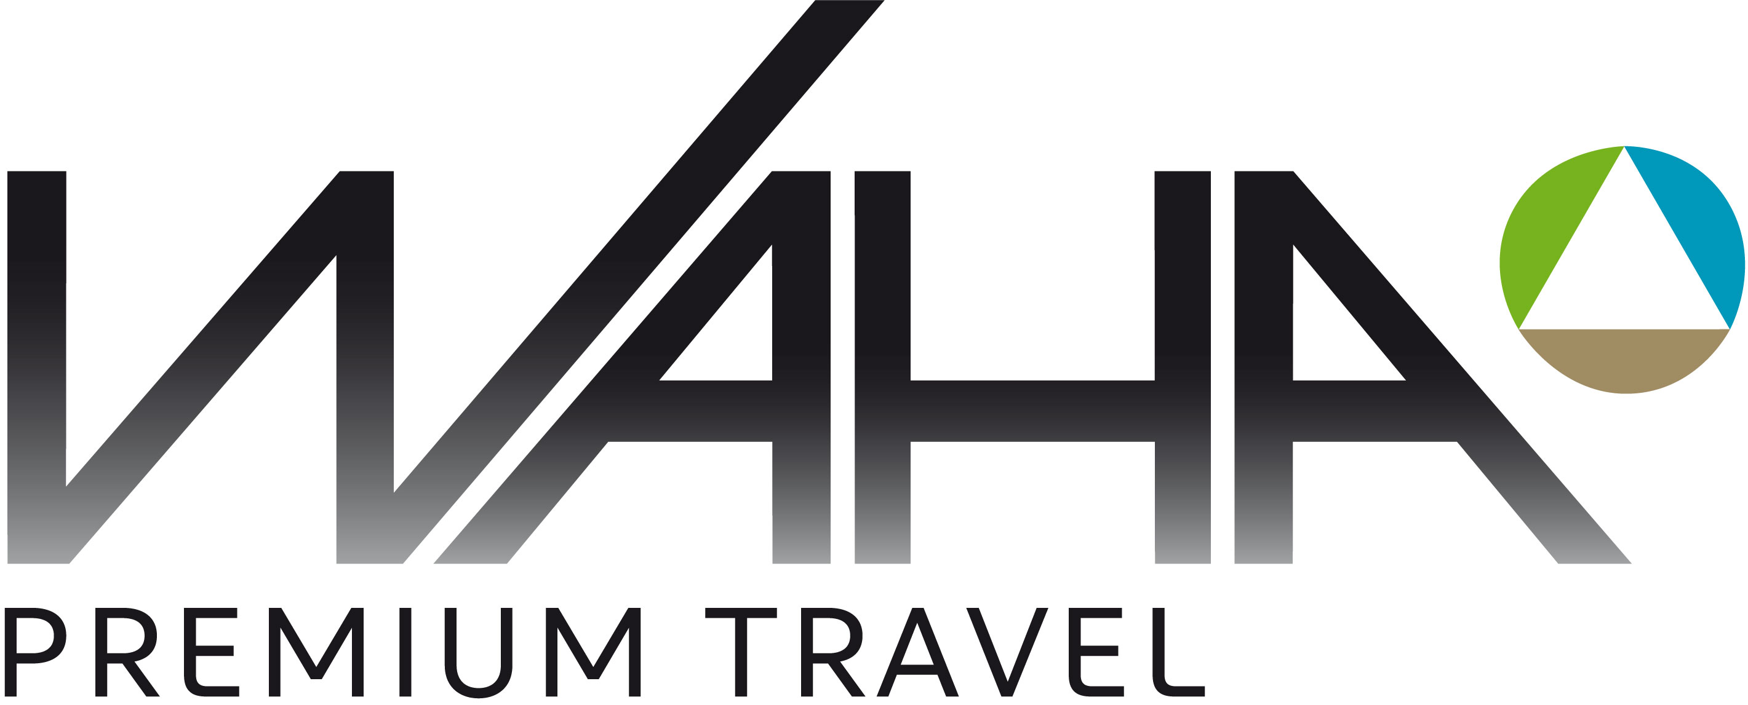
Prices 2023
Bella Coola Eagle Lodge

7 Day Classic Vertical Program
Dates 2023 |  | 7 Days
Dec 31 – Jan 14  Jan 14 – Jan 28  Jan 28 – Feb 04  Feb 04 – Feb 11 |  | C$ 13’524 incl tax  C$ 14’574 incl tax  C$ 15’204 incl tax  C$ 16'989 incl tax
Feb 11 – Apr 08 |  | C$ 17’619 incl tax
Apr 08 – Apr 15 |  | C$ 16'989 incl tax
Apr 15 – Apr 22 |  | C$ 16'254 incl tax
For programs from December 31, 2022, up to February 04, 2023, special incentives do apply. Please call.

5 Day Classic Vertical Program
Dates 2023 | 5 Days
Dec 31 – Jan 14  Jan 14 – Jan 28  Jan 29 – Feb 04  Feb 04 – Feb 11 | C$ 9’849 incl tax  C$ 10’584 incl tax  C$ 11'004 incl tax  C$ 13’209 incl tax
Feb 11 – Apr 08 | C$ 13’734 incl tax
Apr 08 – Apr 15 | C$ 13'209 incl tax
Apr 15 – Apr 22 | C$ 12'684 incl tax
For programs from December 31, 2022, up to February 04, 2023, special incentives do apply. Please call.

Semi-Private Program (up to 8 persons)
Dates 2023 | 7 Days
Dec 31 – Jan 14  Jan 14 – Jan 28  Jan 28 – Feb 04  Feb 04 – Feb 11 | C$ 118'629 incl tax  C$ 121’989 incl tax  C$ 127’659 incl tax  C$ 142’569 incl tax
Feb 11 – Apr 08 | C$ 148'134 incl tax
Apr 08 – Apr 15 | C$ 142'569 incl tax
Apr 15 – Apr 22 | C$ 135'639 incl tax
Counseling and Booking:
WAHA Premium Travel
Schlösslistrasse 9 3008 Bern
Switzerland
Business +41 31 972 66 77
Direct +41 78 662 86 78
info@wahapremiumtravel.com
Private Program (up to 4 persons)
Dates 2023 | 7 Days

Dec 31 – Jan 14 Jan 14 – Jan 28  Jan 28 – Feb 04 Feb 04 – Feb 11 | C$ 77'259 incl tax  C$ 80’724 incl tax  C$ 84’084 incl tax  C$ 94’374 incl tax
Feb 11 – Apr 11 | C$ 98'784 incl tax
Apr 08 – Apr 15 | C$ 94'374 incl tax
Apr 15 – Apr 22 | C$ 89'754 incl tax

For additional programs and prices please call.
For ‚Classic/Semi Private/Private Plus’, ‚Classic XL’ and ,Lodge to Lodge Safari’ programs please call.
Single rooms – as far as available – at extra cost.

